**Function call**

Function call is a jumping / transferring statement used to invoke or recall functions several times and in anywhere.

**Syntax: functionName( [ param1, param2 …. paramN ] );**

**Example:**

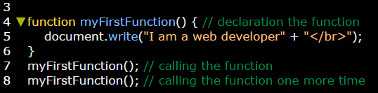

**How function call executes:**

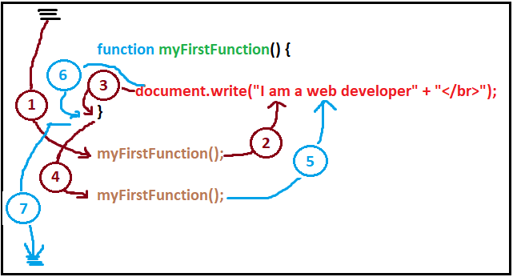

**Illustration:**

The Cursor executed all above statements then moves directly to the first function call statement **(1)** to know which function should be executed first (it know this function from its name) then it **jump** back to the body of this function to execute it’s statements **(2).** After executing these statements it out from this function **(3).** After executing the first function call it moves to the second function call **(4)** and repeat again the cycle.

**Note:**

You can make sure from these steps by running the function codes in source tool and press step into next function call (button inside the yellow circle)

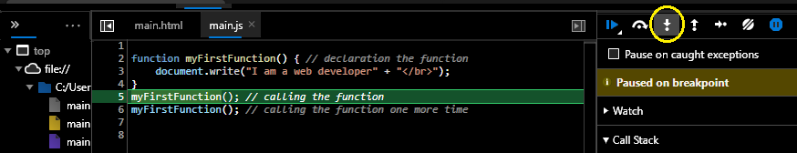

See [Call Stack.docx](Call%20Stack.docx)

**Example 2: on calling nested functions:**

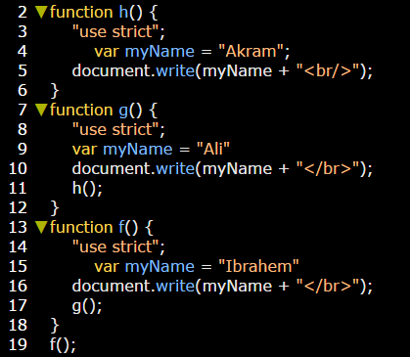

**Illustration:**

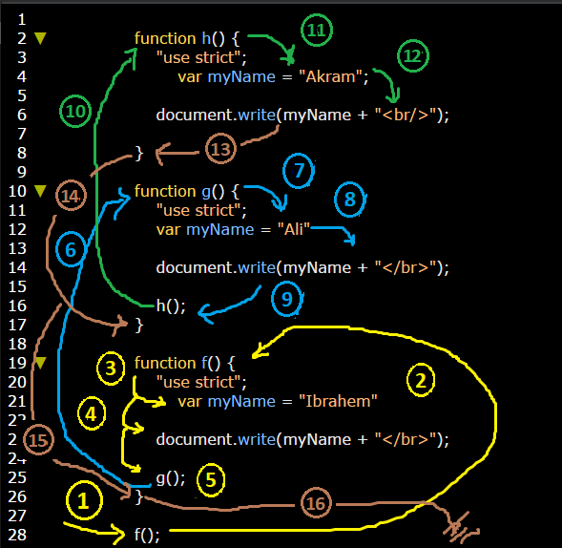

**You can check call stack for this nested functions in source tool.**